
Patuakhali Science and Technology University
Faculty of Computer Science and Engineering
CCE 310 :: Software Development Project-I

Sessional Project Proposal

Project title : CareSync – Family Health Organizer & AI Assistant

Submission Date : Fri 18, July 2025

Sumitted By | Submitted To
MD.Sakib Hasan  ID: 2102052,  Reg: 10179,  Semester: 5  (Level-3, Semester 1) | 1. Prof. Dr. Md Samsuzzaman  Professor,  Department of Computer and Communication Engineering,  Patuakhali Science and Technology University.  2. Arpita Howlader  Associate Professor,  Department of Computer and Communication Engineering,  Patuakhali Science and Technology University.

Table of Contents
- Abstract..........................................................................................................3
- Objectives.......................................................................................................3
- Problem Statement................................. .................................................. 3
- Related Work ................................................................................................3
- Scope ............................................................................................................. 4
- Methodology ............................................................. ................................. 5
6.1. Technology Stack ....................... ................................................. 5
6.2. Design Principles ........................................................................... 5
6.3.Project tree ……………………………………………………….. 6
- Visual Models ..............................................................................................10
7.1. Flow Chart Diagram ......................................................................10
7.2. ERD (Entity Relationship Diagram) .............................................11
7.3. Timeline (Gantt Chart) ..................................................................11
- Limitations ................................ .................................................................12
- Result ...........................................................................................................12
- Bibliography ...............................................................................................13

1. Abstract
CareSync – Family Health Organizer & AI Assistant is a mobile application designed to help families manage health information in one place. It allows users to track multiple profiles, set medication reminders, share health reports, and receive AI-based health support. The app addresses common issues like missed medications, scattered records, and lack of emergency readiness. Built with modern tools like Flutter, Firebase, and GPT AI, CareSync offers a secure, user-friendly solution for coordinated family health management.

2. Objectives
The primary goal of CareSync – Family Health Organizer & AI Assistant is to simplify and streamline health management for families by offering an all-in-one digital platform. The specific objectives are:
- To allow users to manage multiple family members’ health profiles within a single app
- To provide automated medication and appointment reminders
- To support emergency preparedness through real-time alerts and shared reports
- To offer AI-powered assistance for basic health questions and symptom guidance
- To ensure data security, accessibility, and ease of use across all age groups
- To improve communication between patients, caregivers, and healthcare providers

3. Problem Statement
Managing the health of an entire family presents numerous challenges, especially when responsibilities are spread across multiple individuals and generations. In many households, medical records are scattered, medication schedules are forgotten, and emergencies are handled without readily available information. Most health apps today are designed for single users, lacking the flexibility to manage multiple profiles or address family-wide health concerns.
Additionally, there is often a lack of intelligent support when users need quick, reliable health advice for minor symptoms or questions. During emergencies, the absence of organized, accessible health data can lead to delays in treatment or poor decision-making.
CareSync aims to bridge this gap by offering a centralized, multi-user, AI-supported platform that not only keeps health records organized but also ensures proactive care and emergency readiness for the entire family.

4. Related Work
Several health-related mobile applications are available that offer features such as health tracking, AI consultation, and medical record management. However, most are designed for individual use, and few provide comprehensive family-wide health coordination. Below are some notable examples:
- MyChart
  - Features: Access to personal medical records, appointment scheduling, doctor messaging.
  - Limitations: Designed for individual patients; lacks support for managing multiple family profiles or AI-based assistance.
- Google Fit
  - Features: Tracks fitness activities, heart rate, and daily steps. Integrates with wearables.
  - Limitations: Focused on fitness rather than overall health or medical tracking; no multi-user or family support.
- HealthTap
  - Features: Offers virtual doctor consultations and AI symptom checker.
  - Limitations: No health data management or reminders; not built for managing multiple users in a family.
- Ada Health
  - Features: AI-based symptom assessment and health guidance.
  - Limitations: Useful for self-diagnosis but lacks ongoing tracking, report generation, or shared family health planning.
- Medisafe
  - Features: Medication reminders, pill tracking, refill alerts.
  - Limitations: Strong on reminders, but does not support AI features or multi-user health coordination.
- FamilyWall (partially related)
  - Features: Family calendar, meal planner, location tracking, basic reminders.
  - Limitations: More of a lifestyle organizer; lacks health-specific tools and AI integration.
How CareSync Is Different:
CareSync combines:
- Multi-profile health tracking for the entire family
- Medication reminders linked to each profile
- Emergency alerts with health data and location
- AI-based assistant for basic symptom support and guidance
- Health report generation and sharing
- A unified dashboard that blends physical, mental, and preventive care
This unique combination makes CareSync a complete family health ecosystem, rather than an individual-focused tool.

5. Scope
The scope of CareSync – Family Health Organizer & AI Assistant encompasses the development of a mobile application aimed at simplifying health management for families through integrated digital tools. The app is intended to be used by individuals who are responsible for overseeing the health of multiple family members—such as parents, caregivers, or guardians.
Included in Scope:
- Management of multiple health profiles under one user account
- Scheduling and receiving reminders for medications and medical appointments
- Tracking vital signs, mood, and health history for each profile
- Generating and sharing personalized health reports
- Real-time emergency alerts with health data and location
- AI-powered assistant for basic symptom checks and health guidance
- Cloud-based backup and secure data storage
- Cross-platform support (Android and iOS)
Out of Scope (for initial version):
- Direct integration with hospital databases or electronic health records (EHR)
- Real-time consultation with doctors or healthcare providers
- Offline functionality for all features (some require internet)
6. Methodology

6.1. Technology Stack
Layer | Technology/Tool
Frontend | Flutter
Backend | Node.js / Firebase Functions
Database | Firebase Firestore
Authentication | Firebase Auth
AI Integration | OpenAI GPT API / Rule-based NLP
Notification System | Firebase Cloud Messaging (FCM)
Cloud Hosting | Firebase / Google Cloud Platform
Analytics & Crashlytics | Firebase Analytics & Crashlytics

6.2. Design Principles
Principle | Description
Simplicity & Clarity | Minimalist UI with clear labels and easy navigation
Accessibility | Large fonts, high contrast, and elderly-friendly design elements
Personalization | Custom user profiles, flexible reminder settings, profile photos/tags
Responsiveness | Adaptive layout for all screen sizes, real-time data syncing with Firebase
Security & Privacy | Encrypted health data, secure login, consent for data sharing
Calm Technology | Gentle notifications, low-friction interaction, health data shown clearly

6.3 Project Tree
CareSync/
├── assets/
│ ├── icons/
│ ├── images/
│ └── fonts/
│
├── lib/ # Main source code (Flutter) OR src/ for React Native
│ ├── main.dart # Entry point (Flutter)
│ ├── app/
│ │ ├── routes.dart
│ │ └── theme.dart
│ ├── models/ # Data models
│ │ ├── user_model.dart
│ │ ├── profile_model.dart
│ │ ├── health_data_model.dart
│ │ └── reminder_model.dart
│ ├── services/ # Logic & APIs
│ │ ├── auth_service.dart
│ │ ├── health_service.dart
│ │ ├── reminder_service.dart
│ │ ├── ai_service.dart
│ │ └── emergency_service.dart
│ ├── screens/ # UI Screens
│ │ ├── auth/
│ │ │ ├── login_screen.dart
│ │ │ └── register_screen.dart
│ │ ├── dashboard/
│ │ ├── profile/
│ │ ├── health_input/
│ │ ├── reminders/
│ │ ├── reports/
│ │ └── emergency/
│ ├── widgets/ # Reusable components
│ │ ├── health_card.dart
│ │ ├── reminder_tile.dart
│ │ └── report_chart.dart
│ └── utils/
│ ├── constants.dart
│ ├── validators.dart
│ └── helpers.dart
│
├── test/ # Unit & widget tests
│ ├── auth_test.dart
│ └── reminder_test.dart
│
├── backend/ # Optional: Custom backend (if used)
│ ├── api/
│ │ ├── index.js
│ │ └── ai_controller.js
│ ├── models/
│ ├── routes/
│ └── database/
│
├── .env # API keys and env vars
├── pubspec.yaml / package.json
├── README.md
└── LICENSE

7.Visual Models

7.1. Flow Chart Diagram

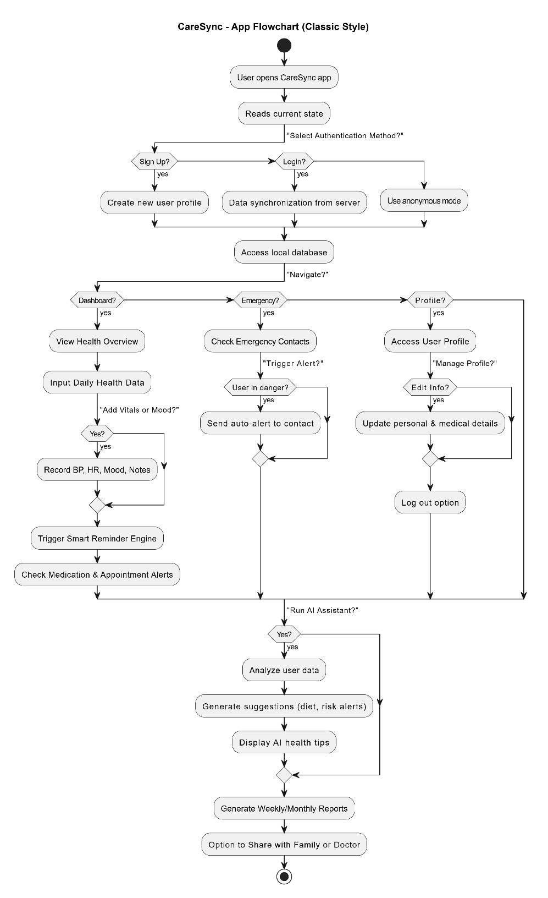

7.2 ER Diagram :

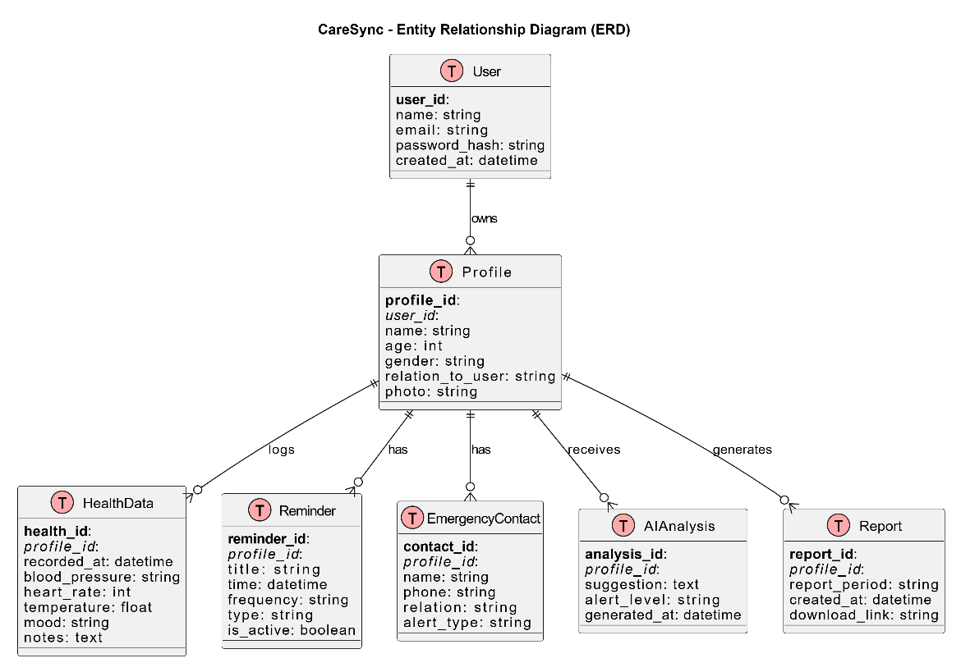

7.3 Grant Chart

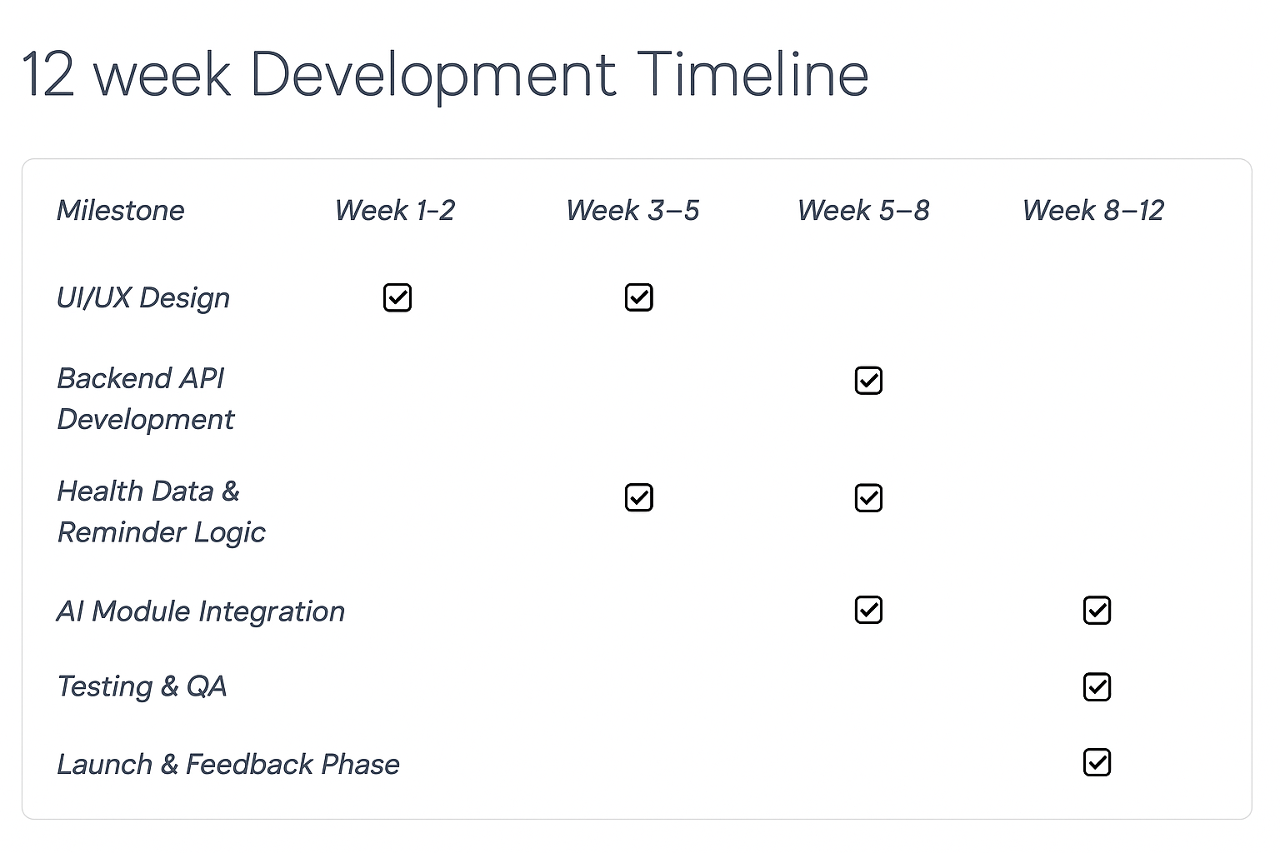

8. Limitations
Despite its robust features and thoughtful design, CareSync currently faces a few limitations:
- Offline Functionality: The app requires internet connectivity for real-time synchronization and AI advice. Offline mode is limited to cached health data only.
- AI Accuracy: While GPT-powered suggestions and rule-based alerts assist users, they are not a substitute for professional medical advice. Misinterpretation or over-reliance on AI suggestions could pose risks.
- Device Dependency: Users must own and manage smartphones or tablets to access the app, which could be limiting for elderly users or those less tech-savvy.
- Privacy Concerns: Although data encryption and user authentication are implemented, storing sensitive family health data always presents potential cybersecurity concerns.
- Platform Support: Currently, the app supports only Android. iOS and web versions are under development.
- Limited Emergency Integration: Emergency contact alert systems are restricted to SMS and in-app notifications; integration with local health services is not yet available.

9. Result
The development of CareSync successfully delivered a minimum viable product (MVP) that meets core goals:
- Users can register multiple family members and manage health data independently for each.
- Health data inputs (mood, vitals, medications) are recorded and visualized per profile.
- AI-driven health suggestions and alerts function using basic rules and GPT integration.
- Reminders for medicine, appointments, and checkups are triggered accurately.
- Emergency alert setup allows pre-defined contacts to be notified instantly.
- Reports can be generated and exported in sharable formats (PDF).
- Overall, the application has proven functional in simulated test environments and received positive early feedback regarding ease of use and value.

10. Bibliography
- OpenAI. (2024). GPT-4 API Documentation. https://platform.openai.com/docs
- Android Developers. (2025). Jetpack Compose & Room Documentation. https://developer.android.com
- Supabase. (2025). Realtime Postgres & Auth Documentation. https://supabase.com/docs
- WHO. (2023). Guidelines on Digital Health Interventions. https://www.who.int/publications/i/item/9789241550505
- Firebase. (2025). Firebase Authentication & Cloud Messaging. https://firebase.google.com
- Nielsen Norman Group. (2023). UX Guidelines for Health Apps. https://www.nngroup.com/articles/healthcare-app-usability/
- React Native Community. (2025). React Native Medical App Examples (GitHub Repos)
- Government of Bangladesh. (2024). Digital Health Strategy & eHealth Policy Guidelines

